5. conclusions
New air-water flow measurements were performed in skimming flows on a large stepped chute physical model as it is pictured in Figure 5.1.
The test section was a 1 m wide with an upstream 0.6 m long broad-crested weir with upstream rounded. The broad-crested weir was followed by ten identical marine ply which were 0.10 m high and 0.25 m long. This corresponded to a 22° slope. Two types of phase-detection intrusive probe were used: some single tip conductivity probes (Ø=0.35 mm) and some double-tip conductivity probes (Ø=0.25 mm). All measurements were conducted downstream of the inception point, on the channel centreline (z=0) and at step edges.
When two single tip probes were used, the reference probe was placed on the channel centreline (z=0) and the second probe was fixed at a known transverse distance z. When double-tip conductivity probes were used, the streamline distance between the two sensors was measured by the microscope. For each discharge, the probe was moved from y=0 up to y=150 mm. Data were recorded at 20 kHz for 45 s with a minimum of 30 measurement points per cross section. This represented 900,000 samples per measurement point. An advanced signal processing technique was developed and applied: correlation and statistical analyses were done at each step edges for all discharges to investigate the air water flow properties. The air-water flow properties presented basic characteristics similar to previous studies in skimming flows at macro and microscopic level. At macroscopic level, they included the distributions of void fraction, the bubble count rate, interfacial velocity and turbulence; whereas at microscopic level similar characteristics were seen in terms of bubble chord distributions, auto and cross- correlation functions. The present findings are significant because they provide a picture general enough to be used, at a first approximation, to characterise the air-water flow field in similar stepped spillway structure.

Void fraction distributions
The void fraction distributions showed an S-shape profile that was observed in previous studies: e.g. RUFF and FRIZELL (1994), CHANSON and TOOMBES (1997) and CHANSON and TOOMBES (2002).

Bubble count rate distributions
Dimensionless distributions of bubble count rate showed consistently a characteristic shape with a maximum about 40-60% void fraction. The maximum bubble count rate was observed for 0.35 ≤ C ≤ 0.6 with most data sets within 0.4 ≤ C ≤ 0.5. A similar results was observed in smooth chute and stepped spillway flows: e.g. CHANSON (1997), CHANSON and TOOMBES (2001), TOOMBES (2002), GONZALEZ and CHANSON (2004).

Interfacial velocity and turbulence level distributions
Air-water interfacial velocities were recorded for three flow rates (d_{c}/h=1.15, d_{c}/h=1.33, d_{c}/h=1.45).
For all flow rates the velocity distributions had the same patterns and they presented a smooth shape similar to earlier results on stepped chutes: e.g. CHANSON and TOOMBES (2002), YASUDA and CHANSON (2003), GONZALEZ (2005). The velocity profiles compared well with a power-law function for y/Y₉₀ < 1. For greater values of y/Y₉₀ the velocity distributions tended to be quasi-uniform. The findings tended to suggest that the upper flow region consisted predominantly of individual water droplets and most droplets were in a free-fall trajectory. Experimental results included further the turbulence. The turbulence intensity reached a maximum for values of y/Y₉₀ ranging between 0.6 and 0.9. It showed a similar trend to the bubble count rate in relation to y/Y₉₀. It is believed that high levels of turbulence extending from y=0 to y=Y₉₀ were caused by the strong aeration and by the continuous deformation and modification of the air-water interfacial structure. Therefore turbulence intensity distribution was strongly related to the bubble count rate.

Flow resistance
Flow resistance in skimming flow is dominated by form drag and cavity recirculation. The equivalent Darcy friction factor was about 0.14 downstream the inception point of free-surface aeration. These results are close to past study in the same facility as it is described in paragraph 3.2.3.

Probability distribution functions of air bubble and water droplet chords
Air bubble (C < 0.3) and water droplet (C > 0.7) chords were analysed in terms of the probability distribution functions. In the bubbly flow region (C < 0.3), the distributions tended to follow a log-normal probability distribution function, they showed a broad spectrum and they were skewed with a preponderance of small bubbles relative the mean size. The maximum values ranged between 0 and 1.5 to 2 mm. The results are consistent with the data of CHANSON and TOOMBES (2002) and GONZALEZ et al. (2005) in skimming flows. In the spray region, the probability distribution functions was flatter than that of the bubble chords and did not follow a log-normal distribution in the upper spray region (C ≥ 0.95 to 0.97). The number and the size of the bubble/droplets detected are strongly related to the size of the sensors as it is highlighted in Appendix C.

Auto and cross-correlation analyses
Correlation analyses yielded a characterisation of the large eddies advecting the bubbles. They were performed for all data collected with two single-tip probes and with the double tip probes. The auto-correlation did not follow a Gaussian error function. For each measurement point and for all flow rates, the cross-correlation function showed a distinctive peak and a Gaussian shape. The cross-correlation function was flatter than the auto-correlation and it was strongly related to the transverse or streamwise separation distance between the two sensors. Basic results included the transverse and streamwise integral scales: they presented the same patterns for void fraction C less than 0.95 even though the auto-correlation time scales T_{xx} were larger than the transverse time scales T_{xy} calculated for different distance Δz. The measurements showed some relatively good correlation between turbulence intensities and integral time scales in the intermediate region between the spray and the bubbly flow region (0.3<C<0.7). The finding suggests that turbulent dissipation by large-scale vortices is a significant process in the intermediate zone..
In the highest region of the spray, C > 0.95 T_{xy} is dropping to zero whereas T_{xx} is increasing. In the upper spray region, the distribution of droplet chord sizes and T_{xx} presented marked difference with the rest of the flow. That suggested a change in spray structure, where the spray region consists primarily of ejected droplets which do not interact with the main flow nor with the surrounding air as it is shown in Figure 5.2.

Energy dissipation
The total head loss (ΔH=H_{max}-H_{res}) for a fully-developed aerated flow equals (CHANSON 2001):
(5.1)
At the downstream end of the chute, the residual head is:
(5.2)
where d is the clear-water depth.
Flow resistance and dimensionless rate of energy dissipation and residual energy at the downstream end of the stepped chute are summarised in Table 5.1.

d_{c}/h | f_{e} | ΔH/H_{max} | H_{res}/d_{c}
1.0 | 0.159 | 0.58 | 2.96
1.15 | 1.126 | 0.54 | 2.85
1.33 | 0.087 | 0.52 | 2.48
1.45 | 0.168 | 0.51 | 2.35
1.57 | 0.160 | 0.40 | 3.32
Table 5.1- Flow resistance, dimensionless rate of energy dissipation and residual energy
at the downstream end

The present results showed a decreasing rate of energy dissipation on the stepped chute with increasing discharge. This has to be considered in designing a stepped spillway. In fact, as CHANSON (2002) suggests, in the event of an exceptional flood leading to an overflow larger than the maximum design discharge, the large residual flow energy might induce substantial damage downstream of the spillway.
Figure 5.1- Experimental test section

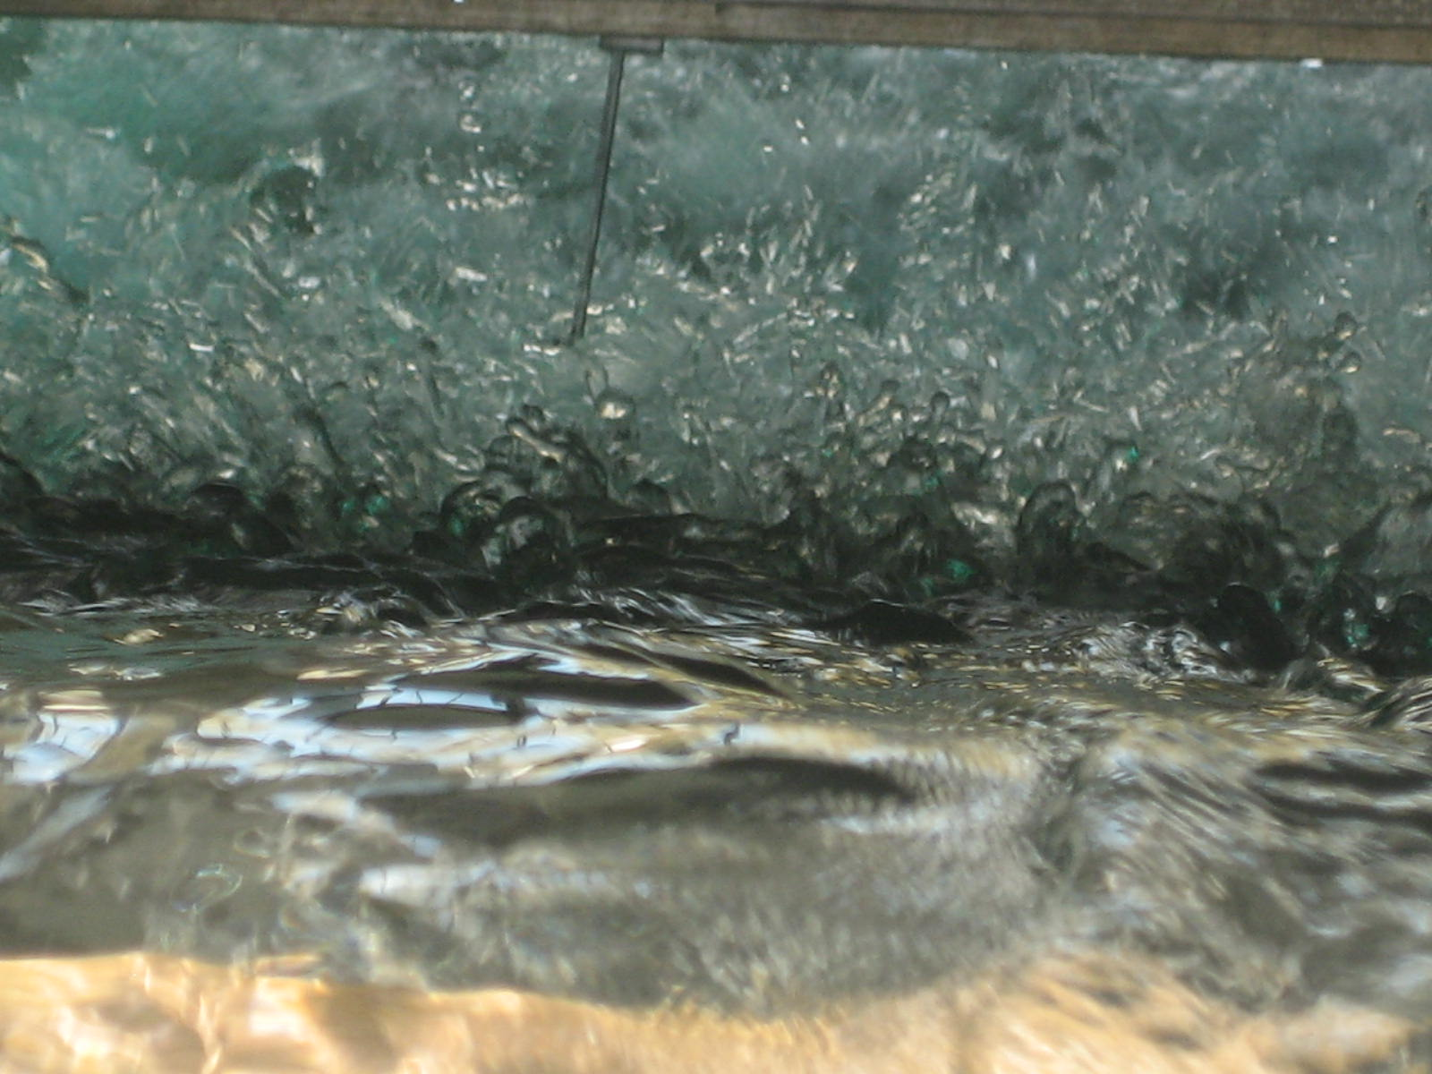
Figure 5.2- Upper spray region looking downstream
d_{c}/h=1.57, step edge No.8, single tip probe (Ø=0.35 mm)

